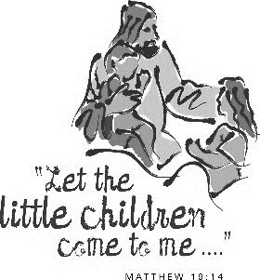
St. Ambrose Parish
Sunday School Registration 2019-2020
Child’s Full name
Grade child is entering in school
Date of birth
Does your child have special needs, learning disabilities, medical issues, or allergies (if yes please provide details)
Father’s name
Mother’s name
(please include maiden name)
Mailing address
Parent Email address
Contact number(s)
Emergency Contact and phone number
Has your child been baptized? | Yes No | If Yes, what church was this at?
Has your child had First Reconciliation (first confession) | Yes No | If Yes, what church was this at?
Has your child received First Communion? | Yes No | If Yes, what church was this at?
- Please provide proof of Baptism for children not baptized at St. Ambrose or Melbourne no later than October 31, 2019
- Registration fee is $20/per child or $30/per family-Cheques can be made payable to St. Ambrose (please note that no child will be refused because of inability to pay)

Saint Ambrose Parish is on Facebook and has a website. We would like your permission to use pictures taken of your child attending Sunday School. I give permission for my child to have his/her picture taken to promote the church programs. YES NO

Signature: Date:

