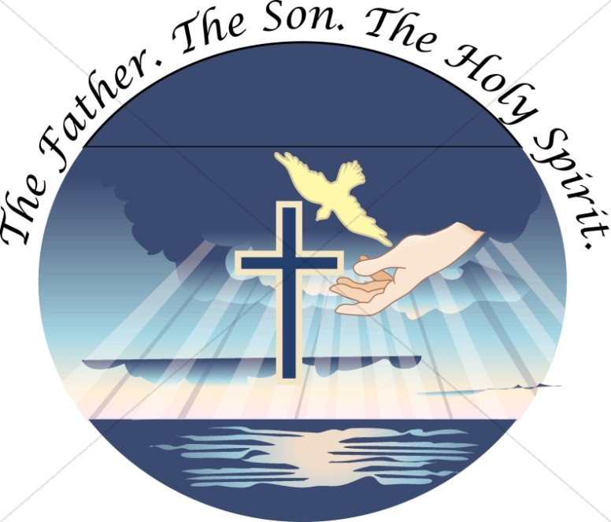

Most Holy Trinity
June 12th, 2022

Pastor: Fr. Henry Smolenaars
Hospital Chaplain: Fr. Wieslaw Papuga
902 - 746 – 8233 (Hospital)
Parish Deacon: Rev. Mr. Stephen Bourque
Fr. Henry Email: frhenrys@gmail.com
Office hours: Monday to Friday
from 9:30 am to 1:00 pm
Church email : stambrosemail@gmail.com
Bulletin email: stambrosebulletin1@gmail.com
Tabitha Centre: 902-742-8960
Reconciliation/confession is held on Wednesday after mass from 7:00-8:00

MASS INTENTIONS –June 11th – 19th 2022

Sat. 4pm Lorna May Burnham and Special Intentions
Sun. 9am Donald G. Parnell and J. Donald Moody
Sun. 10 am (Melbourne) Agnes & Robert Doucette
Sun. 11am Parishioners
Tues. 6:30pm Stephen Gehue and Margaret Talwin
Wed. 6:30 pm Conrad & Mickey LeBlanc and Alfred & Olive
Pothier
Thurs: 9 am Fr. Melvin Stevens and Eli & Celina Hubbard
Fri. 9 am Eva Robicheau and Debbie Muise
Sat. 4 pm Parishioners
Sun. 9 am Intentions of Harriet Gallant and Dora Surette
Sun. 10 am (Melbourne) Edith LeBlanc
Sun. 11 am John Joseph Gehue and Adeline Cook

EMAIL TRANSFERS: are available. Please send to stambrosemail@gmail.com Please add your envelope number or personal information for income tax purposes.

LIVE STREAM MASS AT ST. AMBROSE: We live stream mass every Thursday at 9 am and on the weekend at the Saturday 4pm and Sunday at 11 am mass on a rotating basis. The next scheduled mass is always posted on our website's main page. If you want to watch, go to our web site at www.stambroseyarmouth.ca or go to our YouTube channel www.youtube.com/c/SaintAmbroseParish/videos?view=57

REFLECTION: The Inner Life of God! “All power in heaven and on earth has been given to me. Go, therefore, and make disciples of all nations, baptizing them in the name of the Father, and of the Son, and of the Holy Spirit, teaching them to observe all that I have commanded you. And behold, I am with you always, until the end of the age.” The Trinity! The inner life of God! The Greatest Mystery of our Faith!
We all are used to the idea that there is one God. And we fully accept that this one God is the Father, Son and Holy Spirit. On the surface, this seems like a contradiction. How can God be one and three at the same time? It’s a mystery that is worth penetrating and contemplating.
First, we need to understand that God the Father, Son and Holy Spirit are three divine Persons. Each one distinct from the other. Each Person has a perfect intellect and free will. Each one is capable of knowing and loving to a perfect degree.
But it is this “perfection” of their ability to know and love that makes them one. They each share in the one divine nature and, within that divine nature, are perfectly united. This means that each one knows and loves the other perfectly. And that knowledge (an act of their perfect intellect) and love (an act of their perfect will) brings about a unity so profound and deep that they live and act as one God.
What’s also inspiring to know and understand is that the unity they share by their mutual knowledge and love also offers each one of them perfect fulfillment as a Person. This shows that “personhood” is fulfilled by unity. What a wonderful lesson this is for each of us.
We are not God, but we are made in God’s image and likeness. Therefore, we find fulfillment in the same way that God does. Specifically, we find fulfillment in life by our love of others and our free-will choice to enter into a knowledge of each person, forming a communion with them. This will take on different forms depending upon our relationships. Of course, husband and wife are called to share in the deepest unity in imitation of the life of God. But all relationships are called to share in God’s life in their own unique way.
Reflect, today, as we celebrate this Trinity Sunday, on the relationships to which God has called you. How completely do you imitate the love of the Trinity in your relationships? Certainly, we will all find areas in which to grow. Make a commitment to take another step deeper and, in that step of love, allow God to give you a greater fulfillment as a result.
Father, Son and Holy Spirit, help me to know You and to love You. Help me to discover the love You share within Your own divine life. In that discovery, help me to also love others with Your heart. Father, Son and Holy Spirit, I trust in You. ~ My Catholic Life

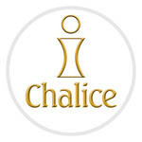
CHALICE: The Eucharist unites us. Not just with people at Mass, but all people formed in the image and likeness of God.
Join Chalice as we celebrate Corpus Christi, June 18-19, and find 2,000 sponsors for children in developing countries. Hear an inspiring message from your priest or deacon at Mass, and learn how Holy Communion invites us to satisfy the spiritual and physical hunger of others. If you wish to sponsor a child, someone will be available with more information when exiting the church.
Sponsored child Mariam, Starehe Girls, Kenya
"I was lucky to be selected for the Chalice sponsorship program, which catered to my school needs, as well as provided a sponsor to walk with me throughout my education journey. Thank you, Chalice, for restoring hope in us."

KNIGHTS OF COLUMBUS NEWS:
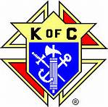
Monthly Meeting: Tuesday June 14th, all members invited!
6:00pm executive meeting
7:30pm general meeting
4th Degree meeting: Tuesday June 21st at 7pm.

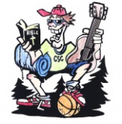
CATHOLIC SUMMER CAMP: We are happy to say Catholic Summer Camp is on for August 7th - 12th at Johnston Christian Park, South Range, Digby County. $200.00 early bird fee if registered by June 30th. After this registration will be $225.00. You can get a registration form at the entrance of the church, the parish office or on the website.

SPONSORSHIP OPPORTUNITY: Every summer, we run a Summer Camp for the youth. Some of the youth struggle to find financial resources to participate in this activity. If you are able and would like to make a contribution to help, send a youth to camp, please submit your donation into the collection at Mass (with pertinent information) or stop by the parish office. Please mark for which activity you are sponsoring.

QUOTE OF THE WEEK: Earthly riches are like the reed. Its roots are sunk in the swamp, and its exterior is fair to behold; but inside it is hollow. If you lean on such a reed, it will snap off and pierce your soul. -St. Anthony of Padua

USHERS NEEDED: We are in need of people to serve as ushers at St. Ambrose. Mostly this ministry includes the collection before the offertory. If you are a man or woman and are interested, please see me (Fr. Henry) after mass.

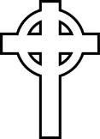

Our sympathy is extended to the family and friends of
Geraldine “Sis” Redfurn
Eternal rest grant unto her O Lord and let perpetual light shine upon her.

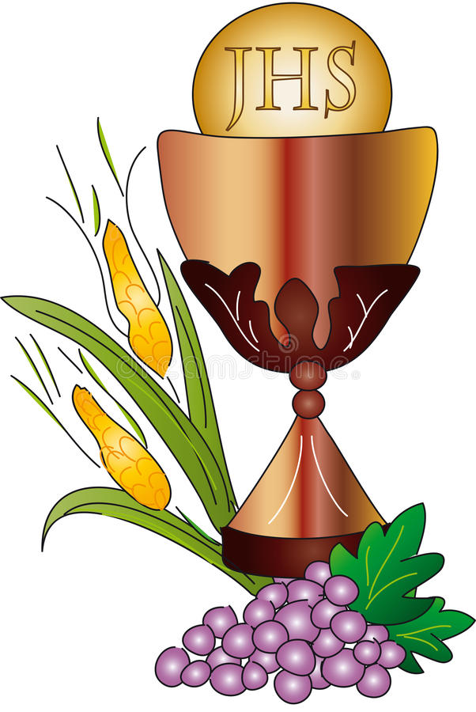
FIRST HOLY COMMUNION: Seven youth of our parish will be making their First Holy Communion this Sunday at the 9am mass. Please keep them and their families in your prayers as they receive Jesus in the Eucharist for the first time.

