#### 

June 15th, 2025

Solemnity of the

Most Holy Trinity

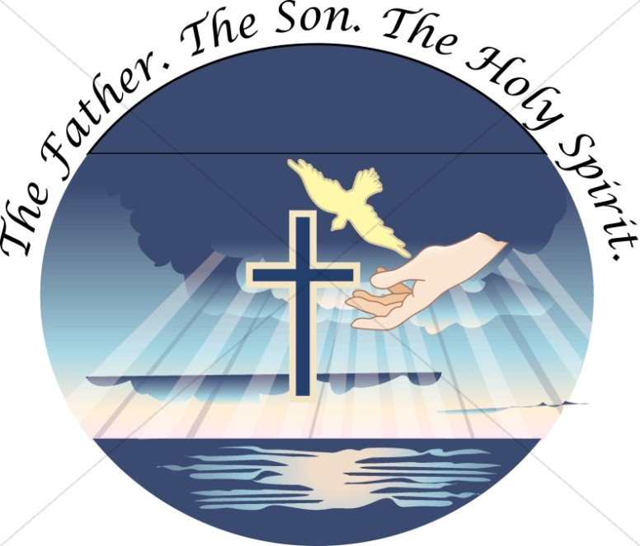

**Pastor:** Fr. Henry Smolenaars

**Fr. Henry Email:** frhenrys@gmail.com

**Hospital Chaplain**:  Fr. Wieslaw Papuga

**Priest on Call:** 902-746-8233 (Emergencies

and Sacrament of the sick)

**Office hours:** Monday to Friday

from 9:30 am to 1:00 pm

**Church email :** stambrosemail@gmail.com

**Bulletin email:** stambrosebulletin1@gmail.com

**Tabitha Centre:** 902-742-8960

**Confession/Adoration** Wednesday 7:00-8:00

**MASS INTENTIONS – June 14th – 22nd, 2025**

**St. Ambrose Co-Cathedral (Yarmouth):**

**Sat. 4 pm** Beatrice Annie Johnson

**Sun.** **9am** Doug & Helen Melanson

**Sun. 11:15am** **Parishioners**

**Tues. 6:30 pm** Russell Frotten

**Wed. 6:30 pm** Donna Freeman

**Thurs. 9 am** Linda Surette

**Fri. 9 am** Alyre Comeau

**Sat. 4 pm Parishioners**

**Sun.** **9am** Siffroi & Estelle LeBlanc

**Sun. 11:15am** Richard Robicheau

**Our Lady of Lourdes (Melbourne):**

**Sun. 10 am June 15th** Madeline & Lellis Surette

**Sun. 10 am June 22nd** Jerome Jacquard

### Image result for free clipart on reflectionRFLECTION The Essence of the Most Holy Trinity “All power in heaven and on earth has been given to me. Go, therefore, and make disciples of all nations, baptizing them in the name of the Father, and of the Son, and of the Holy Spirit, teaching them to observe all that I have commanded you. And behold, I am with you always, until the end of the age.” Of all the great feasts we celebrate within the Church throughout the year, today’s Solemnity presents us with a Mystery that is so deep and transcendent that our eternity will be spent in perpetual contemplation. The Trinity, the life of the Father, Son and Holy Spirit, will never get old, never be fully understood, and will be the cause of our everlasting adoration and joy. Though the Church has used philosophical concepts to explain the Trinity, no human concept or description will ever fully explain Who God is. Though we can point to some general truths about God, we will never be able to fully depict the inner essence, depth, beauty and omnipotence of the Trinity. As we consider that fact, it’s important to understand that the Trinity is not *first* a theological mystery we try to define. Rather, the Trinity is *first* a communion of Persons we are invited to know. We do not primarily come to know God through intellectual deduction. We come to know God through prayerful union with Him. Though theology is exceptionally useful and important, the essence of God is beyond any and every philosophical concept we can define. The Father, Son and Holy Spirit are Persons. And as Persons, they want to be known. And they want to be known primarily through a life of deep and intimate prayer. Praying to One Person, of course, is praying to all, since they are One God. But we are, nonetheless, called to a relationship of love with the Father, the Son and the Holy Spirit. And though our feeble minds may not be able to fully comprehend the essence of God, He will draw us deeper and deeper into a knowledge of Him if we let Him. Prayer often begins by saying prayers, by meditating upon Scripture, and by listening. But true prayer is something much deeper. True prayer is contemplative prayer that ultimately leads to divine union. Only God can initiate this form of prayer in our lives, and only God, through this deep form of prayer, can communicate Himself to us as He is. Some of the greatest mystics of our Church, such as Saint John of the Cross and Saint Teresa of Ávila, explain in their mystical theology that the deepest knowledge of God does not come through concepts or images. In fact, if we wish to obtain a knowledge of God in His essence, we must allow Him to purge every concept of Who He is so that the pure light of His essence can be poured forth upon our minds. This knowledge, they say, is beyond knowing “about” God. It’s the beginning of a knowledge “of” God. Reflect, today, upon the Most Holy Trinity. As you do, say a prayer to God asking for a deeper and more intimate knowledge of Him. Ask Him to communicate to you His divine love and to open your mind and heart to a deeper understanding of Who He is. Try to humble yourself before the great Mystery of the inner life of God. Humility before the Mystery of God means that we know how little we know about Him and how little we know of Him. But that humble truth will help you move closer to the deeper relationship of love to which you are called. *Most Holy Trinity, Father, Son and Holy Spirit, please draw me into a relationship of love with You Who are one God and three divine Persons. May the mystery and beauty of Your life become more known and loved by me each day through the gift of transforming mystical prayer. Jesus, I trust in You.* -My Catholic Life

**CHALICE:** Chalice is coming to St. Ambrose Co-Cathedral! Next Sunday June 21-22 Masses, Canada’s largest Catholic Child Sponsorship organization will provide you the opportunity to begin a relationship with a child in the developing world through the benefits of Child Sponsorship. These are children in extreme poverty who need your support to excel in their education and fulfill their God-given potential. Please visit [chalice.ca](http://chalice.ca) for more information about Chalice and its mission.

**WEEKDAY MASS IN MARIAN HALL:**  Because of the construction happening on Saint Ambrose Church during the daytime, for safety reasons, mass on Thursday and Friday morning will be held in Marian Hall until further notice. (Just on those two days, all other masses will be in the church.)  Fr. Henry

**ST. AMBROSE ROOF FUNDRAISER:** There will be a yard sale/silent auction fundraiser at the Knights of Columbus Hall next Saturday June 21st 8:00am to 2:00pm.  A sign-up sheet is at the entrance for anyone who can volunteer their time on Friday June 20 for setting the yard sale up or Saturday June 21 to help with the sale/clean up.  We are also looking for donations of items in good condition.  For collection services or if you have any questions, please contact Kelley Kelly at 902-740-9490.



Please welcome into our Christian community Ethan Niba Numfor who was baptised on Sunday June 8th, 2025.

Please keep Ethan and his family in your prayers.

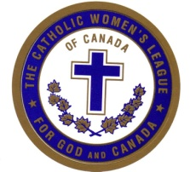**CWL AND FRIENDS:** will meet on Thursday, June 19, 2025 at 5:30 in the Jubilee Room for a potluck social.  Join us for a prayer service and sharing.  We will discuss the teacup fundraiser and activities for the future.  Bring a dish to share.  Dessert will be provided.

**WHAT IS CHILDREN’S LITURGY OF THE WORD?**

Children’s Liturgy is about breaking open the Word of God for young people. The Liturgy of the Word for Children is not “Sunday school” or a catechetics class. Rather, the Liturgy of the Word for Children is a component of the ritual prayer of Mass just as it is for adults. We want to thank those who have assisted in this important ministry during the past nine months during the 11:15 Mass. We will be resuming in September.  If you would like to be a part of this ministry, please call the office and leave your contact information.  A member of the team will call you to discuss and provide training.

**COFFEE SOCIALS:** Will be held after all the masses this weekend June 14th & 15th in the Jubilee room. Please join us for a cup.

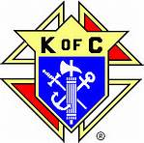**COLUMBUS NEWS: 4th Degree meeting** will be on Tuesday June 17th at 7.00 pm 4th Degree Knights are encouraged to attend.

**MATTHEW 18:** will be cancelled for the next few weeks and will resume when construction on the church is finished. We hope to see you all then!



Our sympathy is extended to the family and friends of

Paul Gerard Doucette

Eternal rest grant unto him O Lord and let perpetual light shine upon him.