
March 29th, 2026
Palm Sunday of the Passion of the Lord

Pastor: Fr. Henry Smolenaars
Fr. Henry Email: frhenrys@gmail.com
Hospital Chaplain: Fr. Wieslaw Papuga
Priest on Call: 902-746-8233 (Emergencies
and Sacrament of the sick)
Office hours: Monday to Friday
from 9:30 am to 1:00 pm
Church email : stambrosemail@gmail.com
Bulletin email: stambrosebulletin1@gmail.com
Tabitha Centre: 902-742-8960
Confession/Adoration Wednesday 7:00-8:00

MASS INTENTIONS – March 28th – April 5th, 2026

St. Ambrose Co-Cathedral (Yarmouth):
Sat. 4 pm Leo Williams
Sun. 9am Parishioners
Sun. 11:15 am Anniversary Fr. Clarence Thibeau
Tues. 6:30 pm No Mass (12:00 pm Chrism Mass in Halifax)
Wed. 6:30 pm Eugene Surette
Thurs. 6:30 pm Holy Souls in Purgatory
Fri. 3 pm Good Friday Service
Sat. 8 pm Easter Vigil Special Intentions
Sun. 9am Mass of Thanksgiving
Sun. 11:15 am Parishioners
Our Lady of Lourdes (Melbourne):
Sun. 10 am March 29 Bessie and Peter Thibeault
Thurs. 6:30 pm Vivian Surette
Fri. 3 pm Good Friday Service
Sat. 8 pm April 4 Easter Vigil Mary Ellen Saulnier
IF YOU WOULD LIKE TO BRING UP THE GIFTS in the offertory procession at a weekend Mass (if you are a family member of the person the Mass is for) please see the greeters at least 20 minutes before Mass begins.

REFLECTION: Palm Sunday—A Model of Courage and Determination And when he entered Jerusalem the whole city was shaken and asked, “Who is this?” And the crowds replied, “This is Jesus the prophet, from Nazareth in Galilee.” The commemoration of our Lord’s Passion has begun. Today, Mass begins with the reading of Matthew’s account of Jesus’ triumphal entry into Jerusalem. Riding on a donkey, Jesus is greeted by a very large crowd who “spread their cloaks on the road, while others cut branches from the trees and strewed them on the road”. The people welcome Him with shouts of: “Hosanna to the Son of David; blessed is he who comes in the name of the Lord; hosanna in the highest”. The word “Hosanna” in Hebrew means, “Save us, we pray!” Though it was originally a plea for deliverance, it became an expression of praise and joy, especially as it came to be associated with the Messiah’s arrival. The phrase “Hosanna in the highest” calls for God, enthroned in Heaven, to bring His saving power to earth. The crowds’ acclamation reveals both a hope for salvation and a recognition of Jesus as the long-awaited Messiah. During Passover week, Jerusalem’s population increased several times over with pilgrims from across Israel. The atmosphere was vibrant with religious fervor and communal celebration. Merchants sold sacrificial animals, food, and provisions to the crowds. Central to the festivities was the Temple where sacrifices were offered and the Passover lambs were prepared for the sacred meal. Roman authorities increased security, wary of potential unrest, as the commemoration of Israel’s liberation from Egypt stirred hopes of national deliverance. The Jewish authorities were also on high alert, concerned that any disturbance might provoke harsh reprisals from the Romans. Imagine the excitement, concern, and surprise that many of the religious and Roman leaders felt as large crowds professed their belief in Jesus as the Messiah. Was Israel’s deliverance at hand? This public acclaim highlighted why some saw Jesus as a threat. The Pharisees, in particular, feared that His messianic identity might undermine the religious authority to which they clung. Most of them dismissed the possibility that Jesus was the Messiah they awaited. Jesus, however, had a very different understanding of the Passover that year. He knew it was the time for His hour of suffering and death, leading to His glorification. He had no interest in political maneuvering. His sole desire was to fulfill His mission as the Messiah by becoming the one perfect Lamb of Sacrifice whose blood would atone for the sins of many. Jesus was determined and confident as He rode into Jerusalem. Though He knew the suffering that awaited Him, His gaze was fixed on His mission of saving souls. In His sacred humanity, He overcame every temptation to fear or anxiety, allowing peace, strength, and joy to fill His heart. Not only is Jesus our Savior and the one Mediator between God and us, His human life perfectly models how we are to live. Jesus’ triumphal entry into Jerusalem especially models for us how we are to face every difficult situation that tempts us to fear and anxiety. His courage must become our courage, and His determination our determination. Reflect today on Jesus’ interior disposition during His triumphal entry. He invites us to share in His sacrificial love, laying down our lives selflessly for others. This is only possible if we allow His virtues to take root in us every time, we are called to imitate His love. As we embrace our own mission, we must not allow fear or anxiety to hinder us. Pray that the courage, peace, and steadfast love that Jesus embodied during that first Holy Week may flourish in your heart. Let go of fear, worry, and selfishness, and allow Jesus’ love and strength to fill you, so that His mission may continue through you and, with our Lord, you may lay down your life for others. -My Catholic Life


GOOD FRIDAY FISH CHOWDER FUNDRAISER: On Good Friday April 3rd the fish chowder will be a dine in or take out from 2:00pm to 5:30pm at the Parish Centre dining room. Tickets can be purchased at the parish office in advance or at the door while quantities last for $8.00. The proceeds go to the youth for the Steubenville Atlantic Conference. We appreciate your support!

GOOD FRIDAY FAST AND ABSTINENCE RULES: Every person 14 years of age or older must abstain from (not eat) meat. Every person between the age of 18 and 59 must also fast on Ash Wednesday meaning you can eat the equivalent of two meals that day. For example, you can choose to eat one normal meal and two other meals that add up to one meal.


FOOD BANK: The weekend of April 11th & 12th, is our turn to support the Yarmouth Food Bank. Non-perishable goods and monetary donations are appreciated.
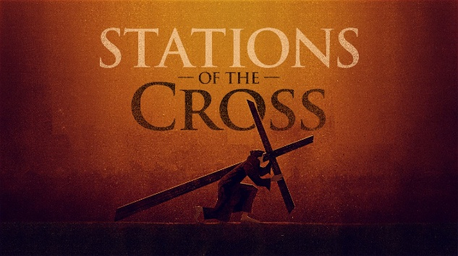
STATIONS OF THE CROSS: Please come and join the parish youth as they perform the Stations of the Cross play. The date of the performance is Good Friday, April 3rd, 2026, at 6:30 pm at St. Ambrose Church.
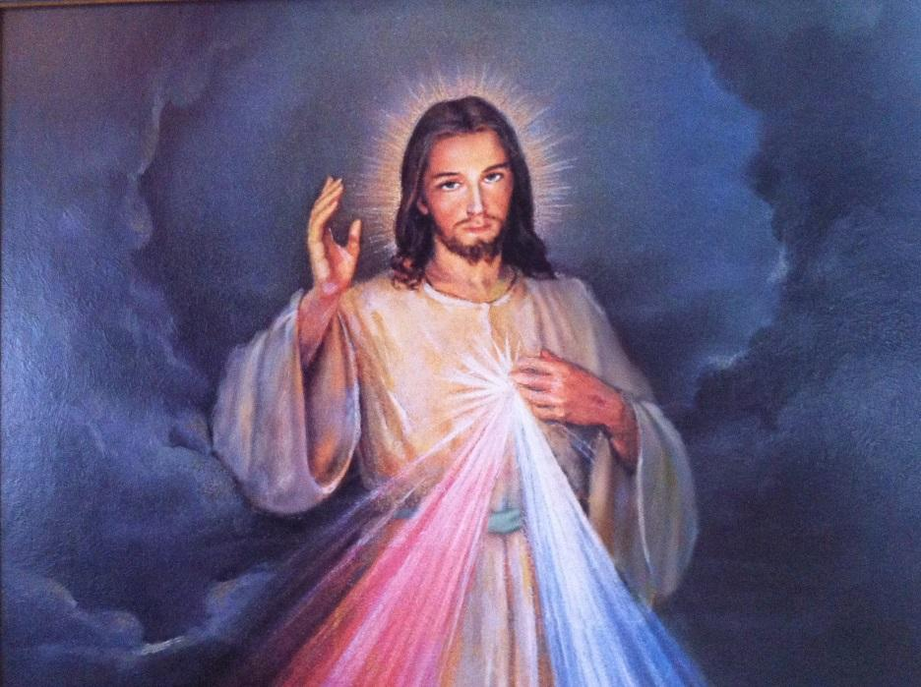
DIVINE MERCY SUNDAY: The first Sunday after Easter (April 12th) is Divine Mercy Sunday. We will be having a Divine Mercy Service at 3pm at St. Ambrose Church. Christ appeared to a Polish nun, Sr. Maria Faustina Kowalska, in a series of visions that took place over almost eight years. Among those visions, Christ revealed the prayer for Divine Mercy. Please come join us in praying this prayer.


ULTREYA: The Yarmouth and Area Ultreya will be held April 9th 2026 at Marian Hall at 7pm. We hope to see you then! De Colores!
HOLY WEEK AND EASTER SCHEDULE:
St. Ambrose Co-Cathedral
Tues., Mar. 31-----------Chrism Mass
12pm (St. Mary’s Basilica)
Tues., Mar. 31--------CHURCH & OFFICE CLOSED
Wed., Apr. 1---------- Mass
6:30pm Wednesday
Thur., Apr. 2-------- Holy Thursday Mass of the Lord’s Supper
6:30pm (St. Ambrose)
Fri., Apr. 3------------ Good Friday Service
3pm (St. Ambrose)
6:30pm Stations of the Cross
Sat., Apr. 4----------- Easter Vigil
8pm (St. Ambrose)
Sun., Apr.5-----------Easter Sunday
9am & 11:15 am (St. Ambrose)
Our Lady of Lourdes Melbourne
Thur., Apr. 2-------- Holy Thursday Mass of the Lord’s Supper
6:30pm (Melbourne)
Fri., Apr. 3------------ Good Friday Service
3pm (Melbourne)
Sat., Apr. 4----------- Easter Vigil
8pm (Melbourne)

